**Final Project Report**

* **A brief recap of your data, goals, and tasks, focusing on those that most directly influence your design**

I decided to look at crime data in L.A. County. I couldn’t get the data or Altair to load on the main Python platform. I found another platform trying to compete with Github, which allowed me to upload all the data that I needed and load Altair. However, the original dataset was too large for this platform, around 125 mil. data points. So I decided to just look at crime involving “Weapons”, so traffic crimes or misdemeanors, or things not involving weapons were removed. Along with null values. After cleaning the data, I had the following dimensions to the dataset: (315888, 20) which is 6,317,760 individual data points. Most of the data had lots of categories with only a handful of occurrences, so most the graphs and charts are only the top 20. This will be stated in the Title in most cases. I felt that for the purpose of this assignment that this would be alright. If I was cleaning and analyzing data for L.A. county, I would have taken more care in how and why I slimed my data down. As the assignment brief said to have around 5000 pieces of data, I felt that over 6 mil. would suffice.

I had 3 goals

1. Get a clear overview of the nature of crime in L.A.
2. I identify any trends in crime.
3. Create Infovis to answer questions, but I have a personal goal to create a working heat map as this has been eluding so far in my previous courses that I have taken.

* **Screenshots of and/or a link to your visualization implementation. These are not in order of creation but order of complexity. It may or may not be the order that I would present them in a presentation.**

First bar chart to break the ice.

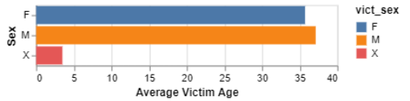

I only had one column of quantitative data, Victims Age. Below are three box plots the first two are not interactive, the last one is, as you hover over different parts it gives you the values.

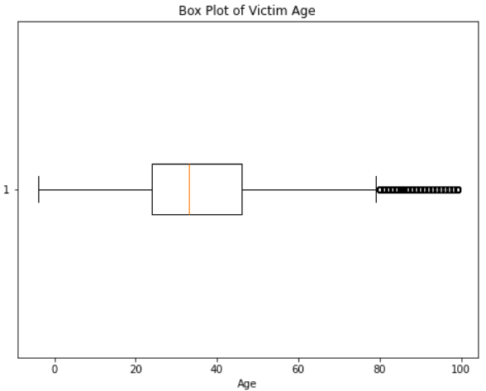

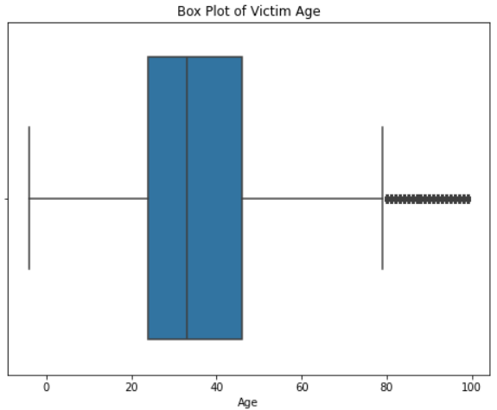

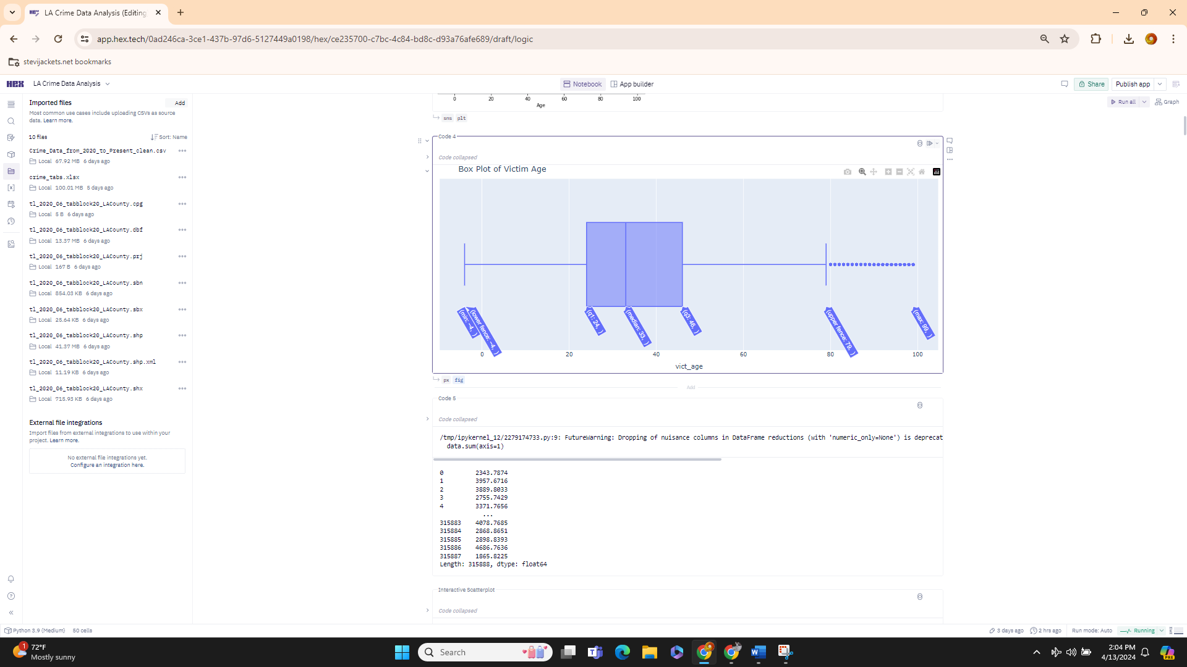

The rest of the data was all categorical, so I had to get creative. Boring data first, nothing fancy here just raw numerical data.

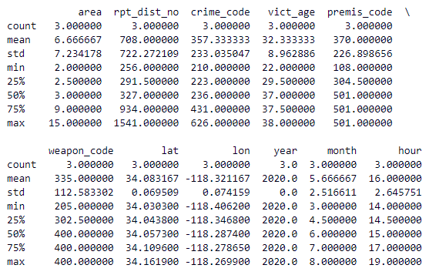

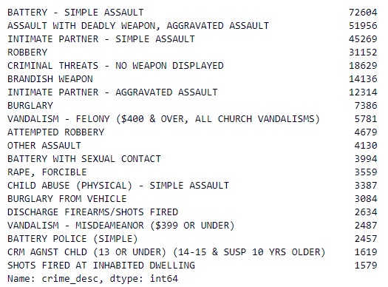 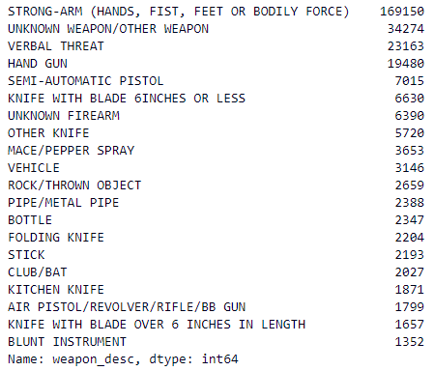 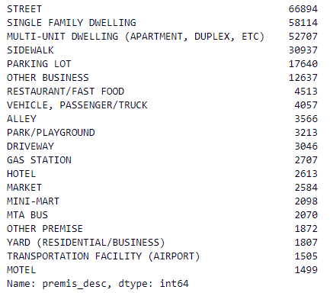

Some basic interacitve pie charts. As you hover over the different areas it the category name and the count of that piece.

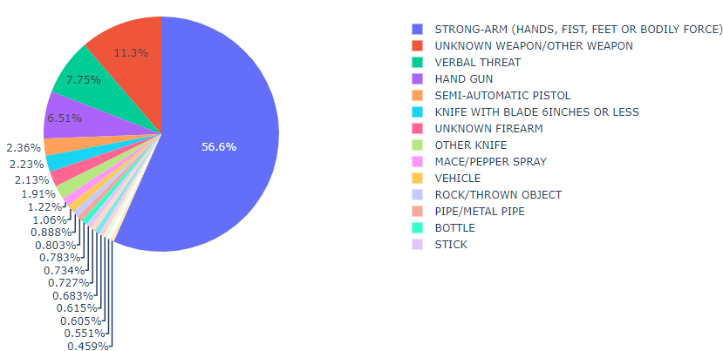

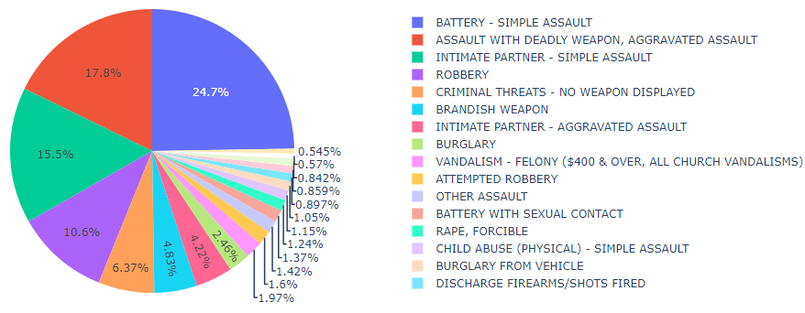

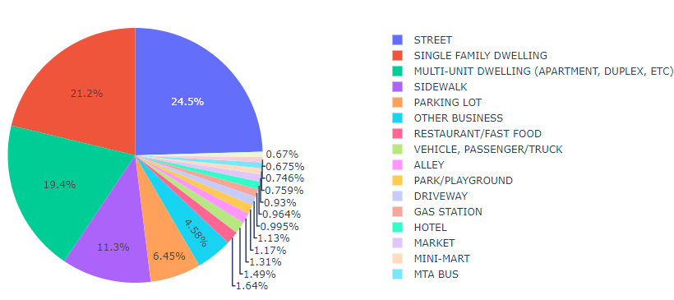

Some Bar Charts

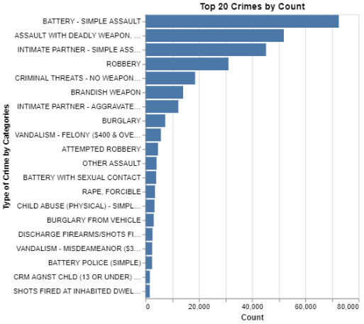

Same thing but interactive

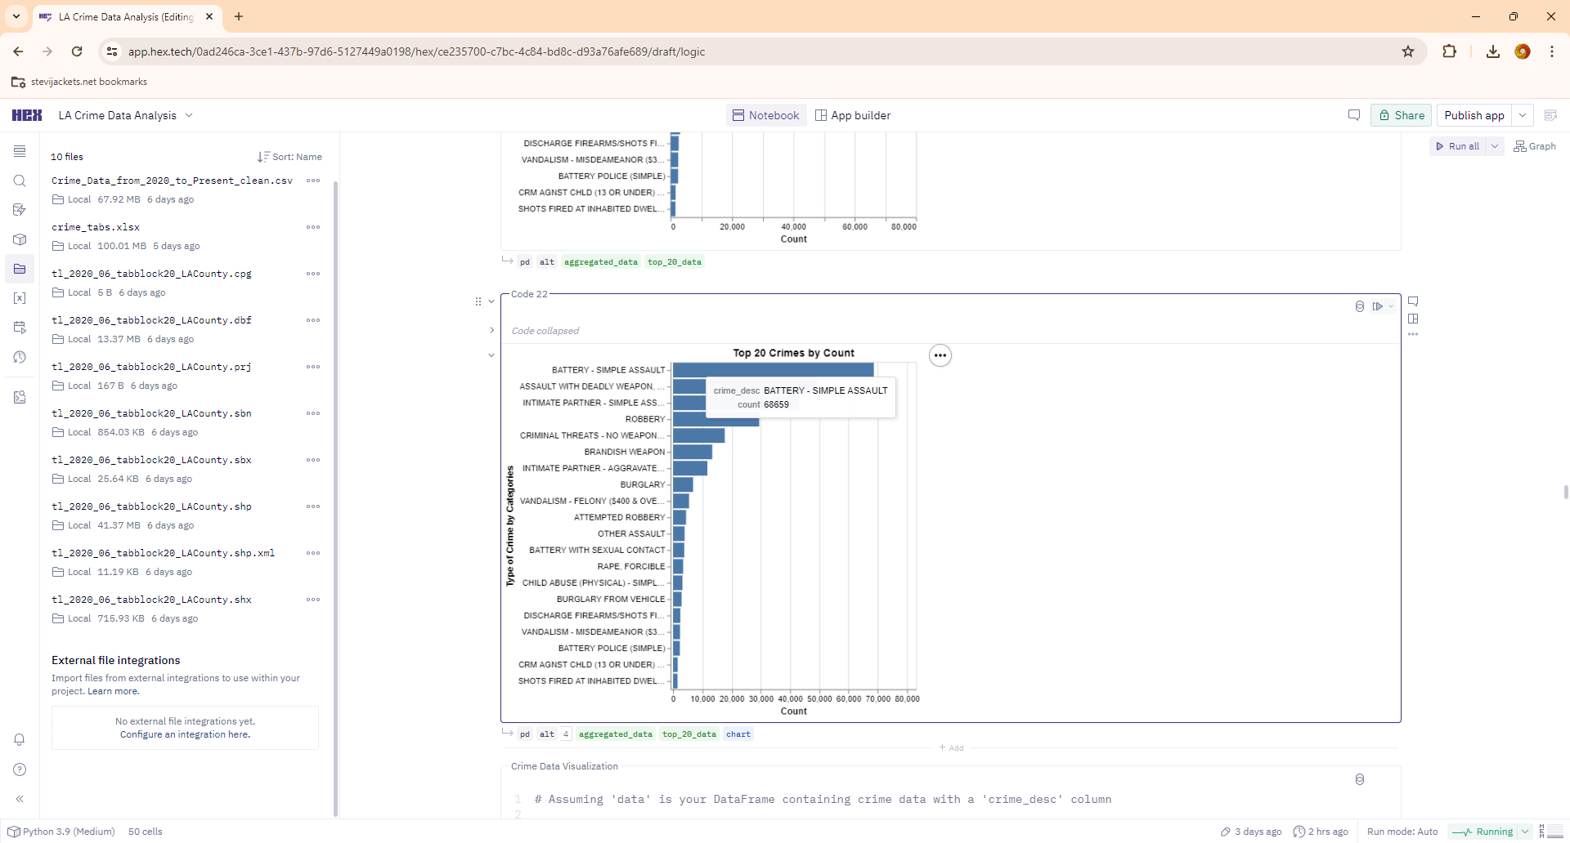

I had similar bar charts for Area/District of Crime, Location of Crime, and Type of Crime.

I wanted to look at crime rates over time. I’ll have a few iterations below.

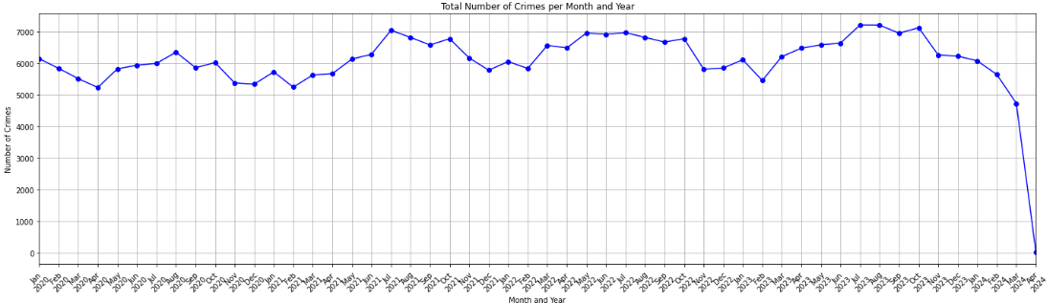

This one had the drop on the far right, where I didn’t have a whole months’ worth of data, so it looked like crime had drastically improved. Here it is adjusted but to a wrong scale.

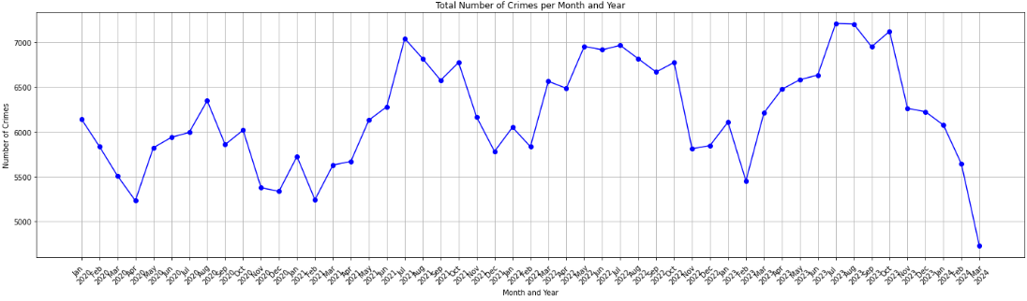

Here it is to the correct scale.

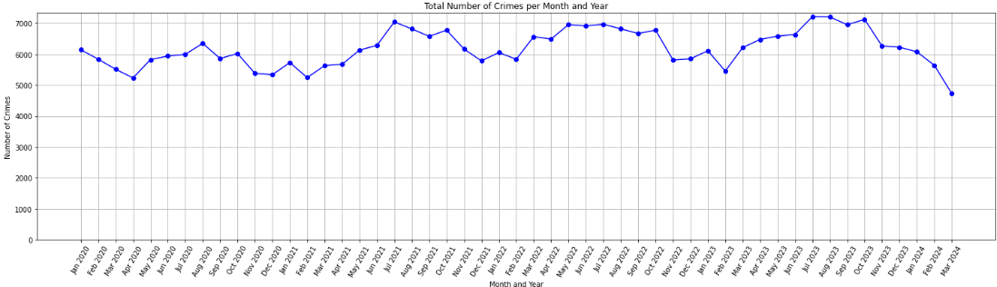

Here it is interactive

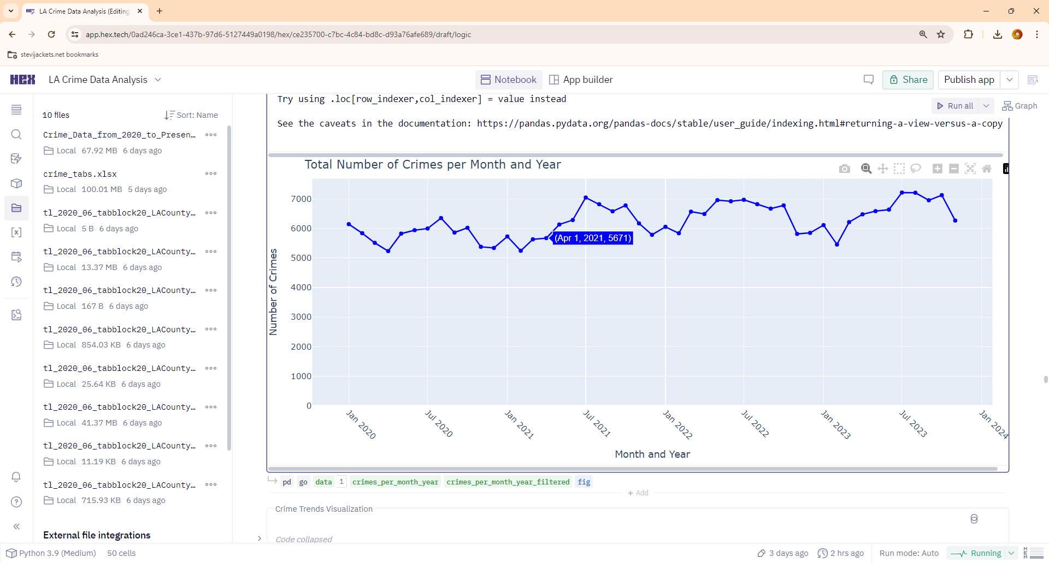

Here it is with the years overlayed, but with no month names.

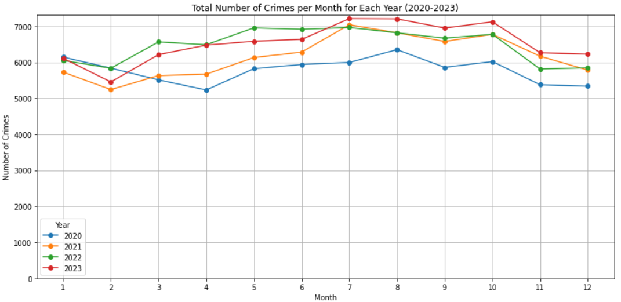

Here it is fixed with month names.

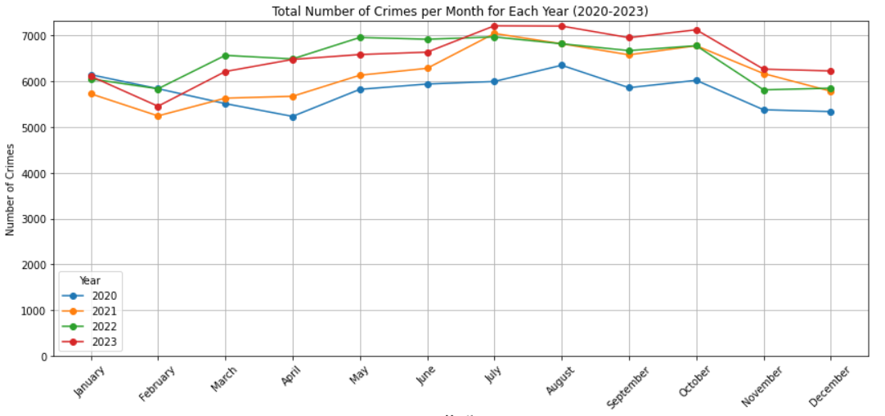

Here is my first attempt at crimes by hour of the day.

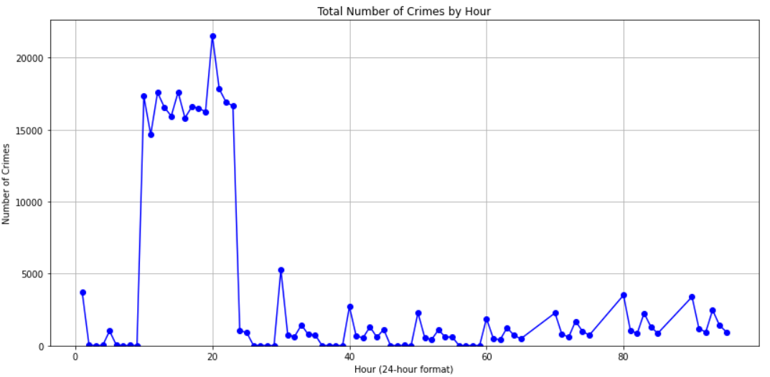

Here is a better attempt.

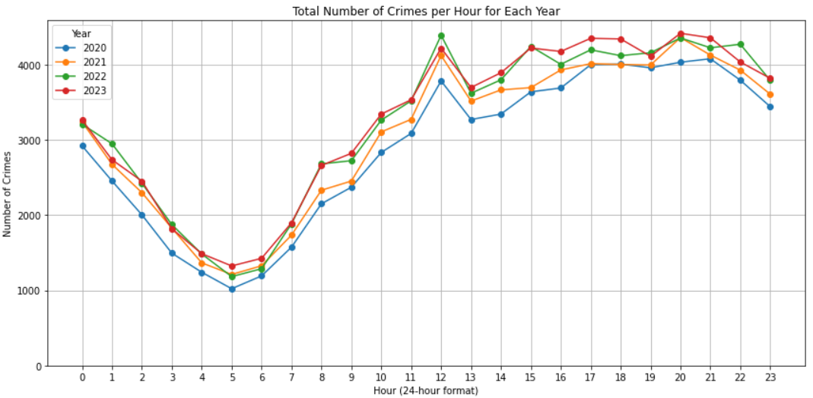

Here is the interactive attempt.

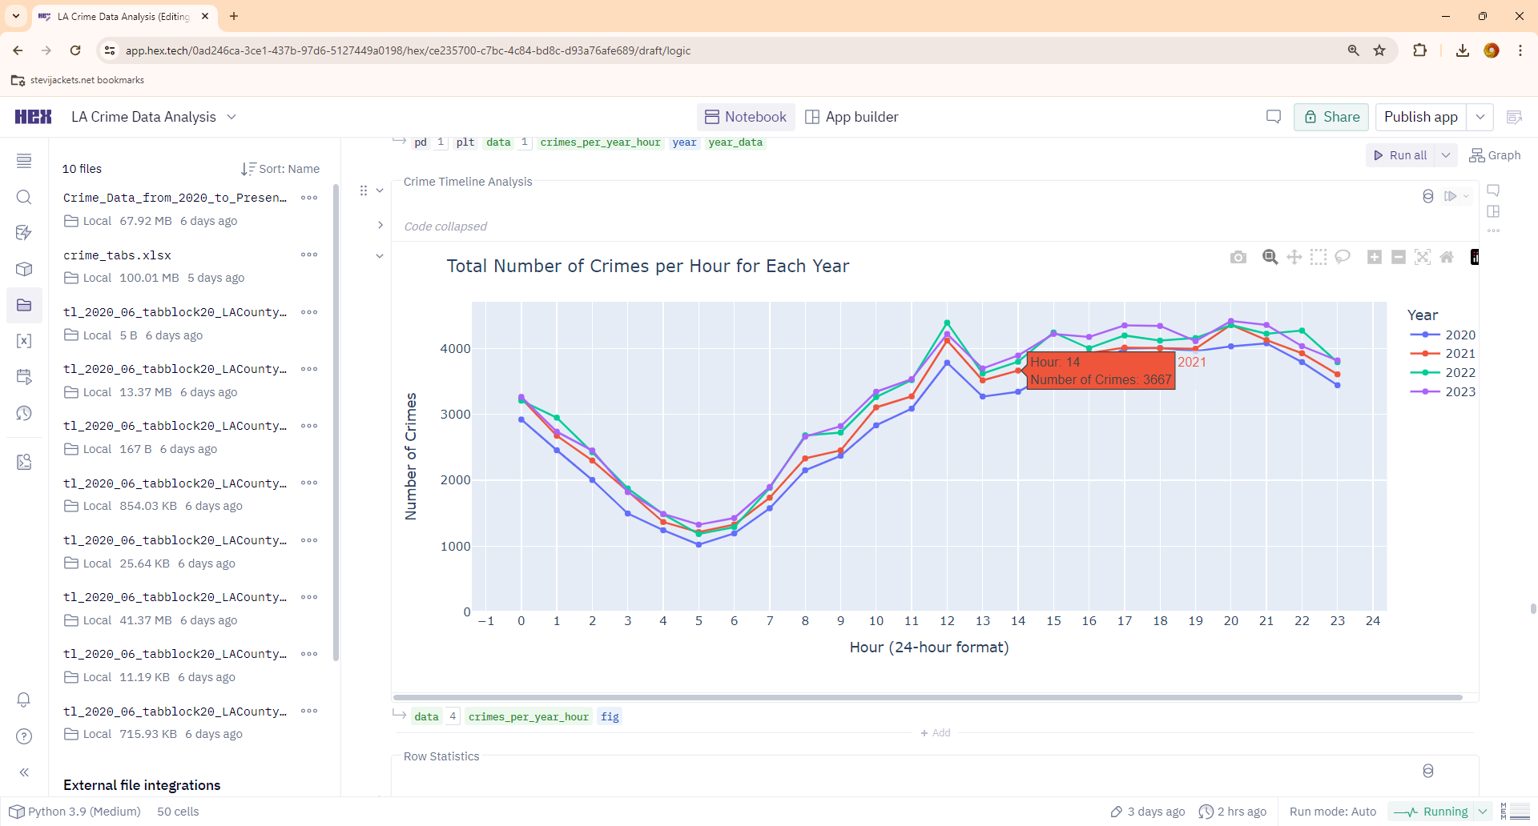

I then moved on to heat maps

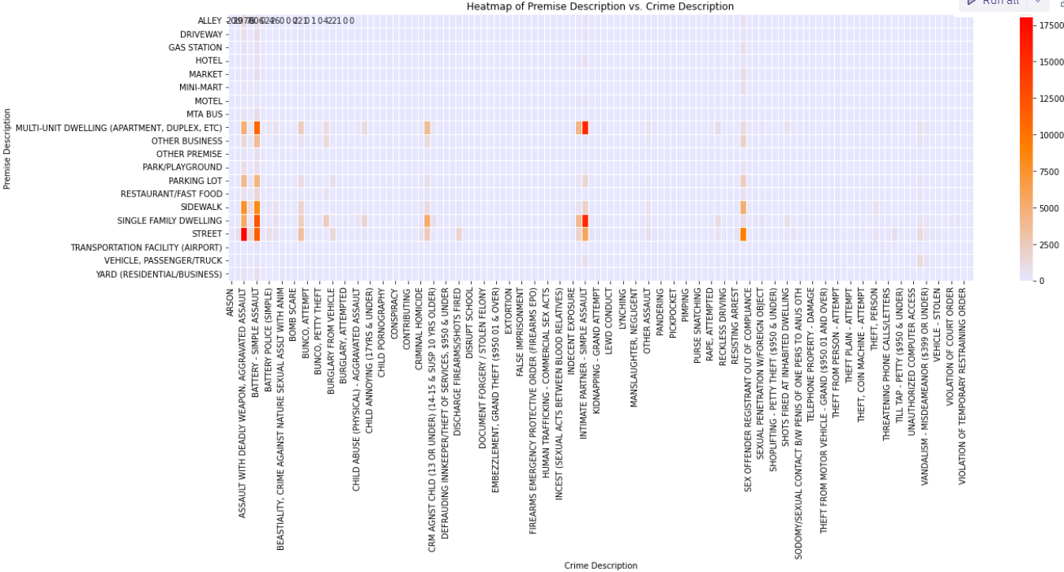

I had about six of these with the top 20 category on the Y-axis and all the secondary data on the X-axis. There were different combinations of Weapon, Premises, and Crime

I then remember to convert it to a Log Scale to get more variations.

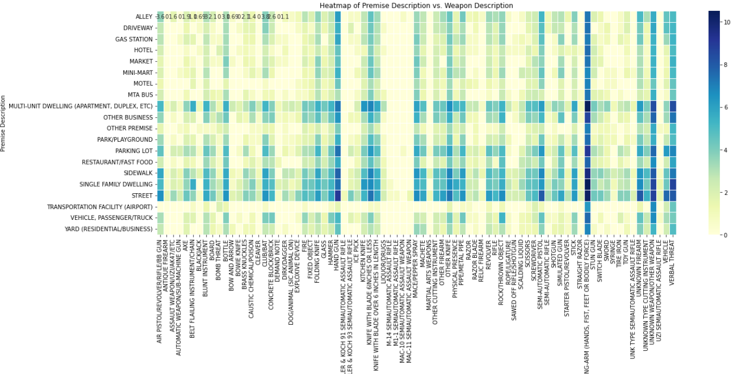

I then added counts, which didn’t really work as a visualization.

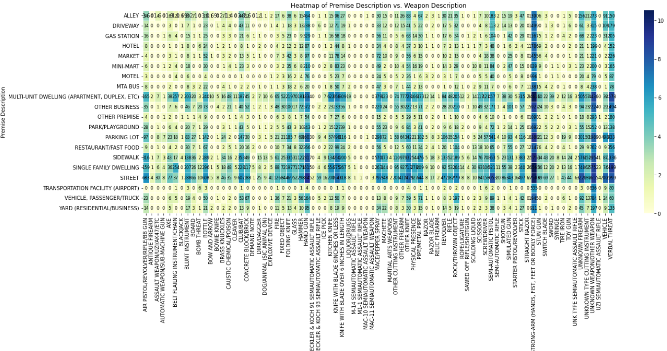

I then made it interactive, which sort of worked but the hovering over an area was more frustrating than helpful. Here is a picture anyway, if you look closely, you can see a count of 72, I had more information, but like I said it was very frustrating to use. I settled on just a “count” in the end.

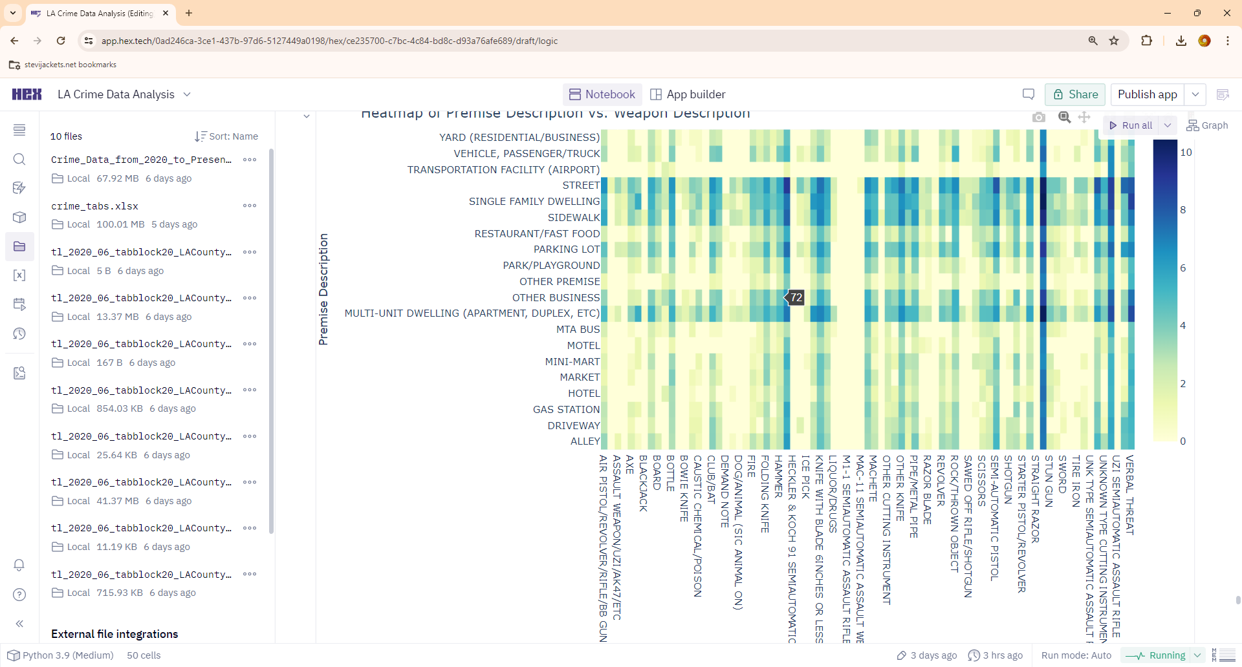

Next, I had two scatter graphs. As this was all categorical data, I used the codes for x and y axis. These went through numerous iterations. They ended up being more like a heat map and less like a scatter graph.

This first one was a mouse hover select

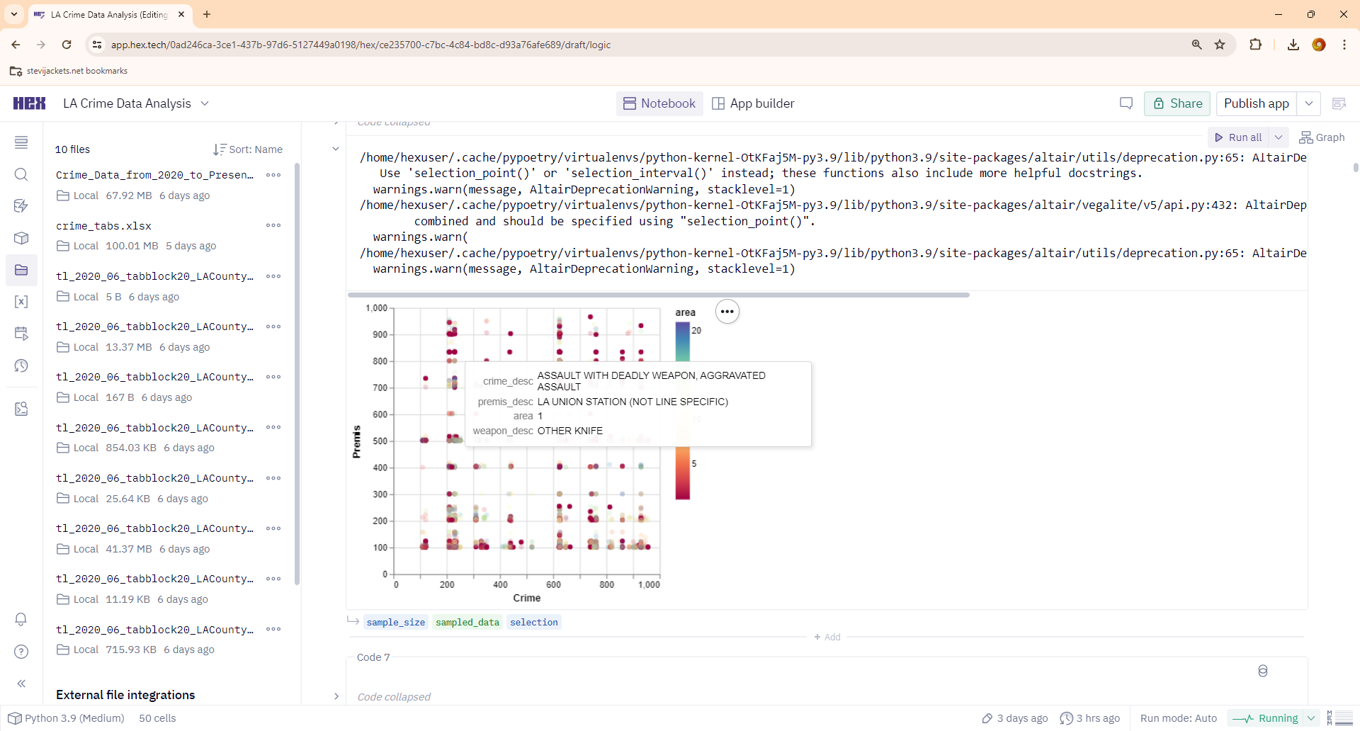

This one was a mouse click select, which I felt was nicer to work with.

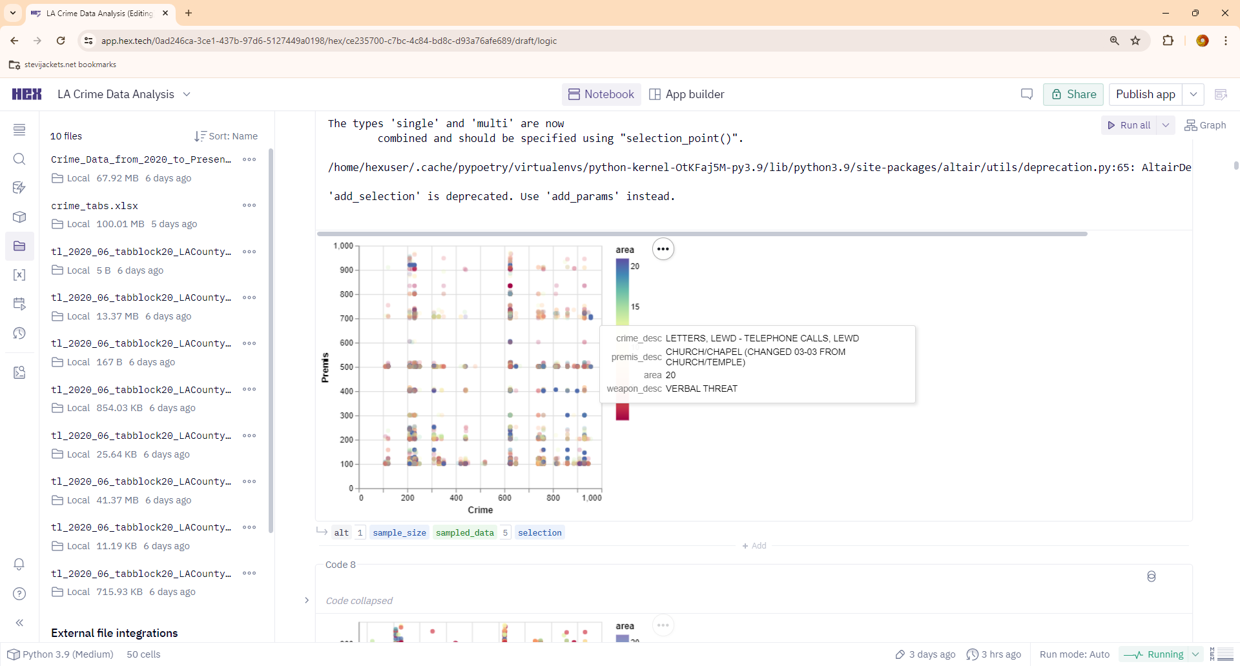

This one allowed me to hover and zoom. The scale is really zoomed in on a particular “premis” and “crime” code combination.

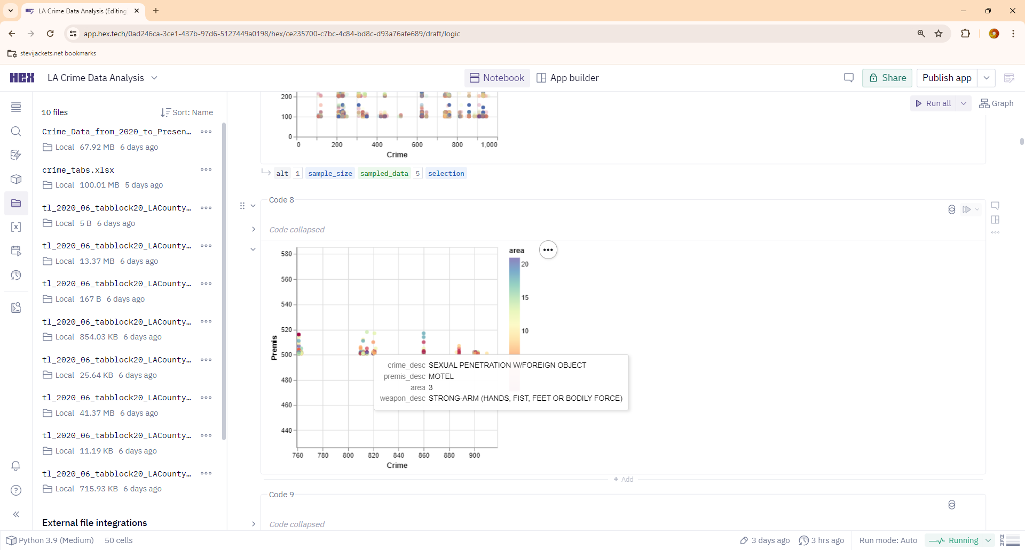

Finally, my pride and joy of this assignment. I managed to get some great area heat maps with two interactive ones.

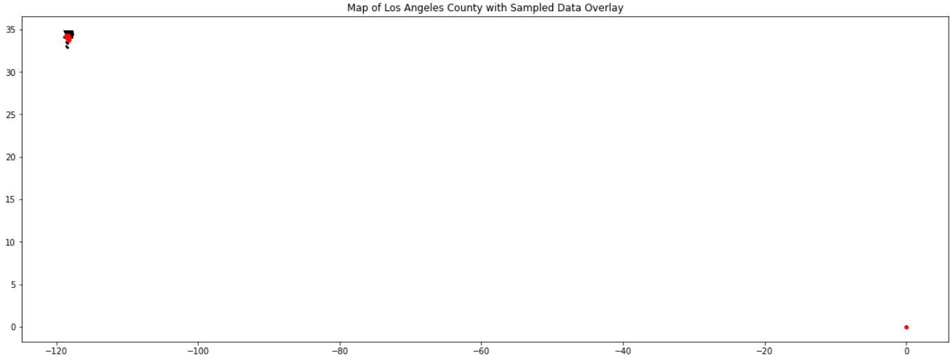

This is the first one with all the unknown locations entered in as (0, 0), hence the skew and red dot in the bottom right corner. Didn’t know this until I made this first attempt. I then had to “clean” this data out of the map.

Second attempt.

The whole “shp” file. This was tricky. Finding the right type of file to download was a lot of work. I would have liked to have found one with just area boundary lines and not everything including roads. But for my first successful attempt, I’m pretty happy with the overall results.

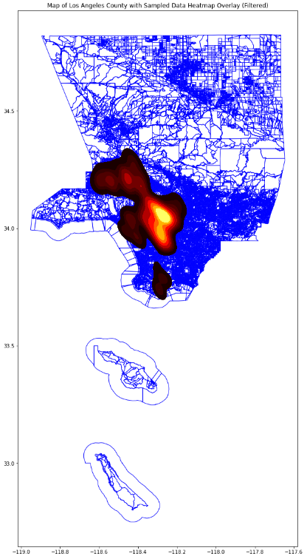

Better but I knew I could do more.

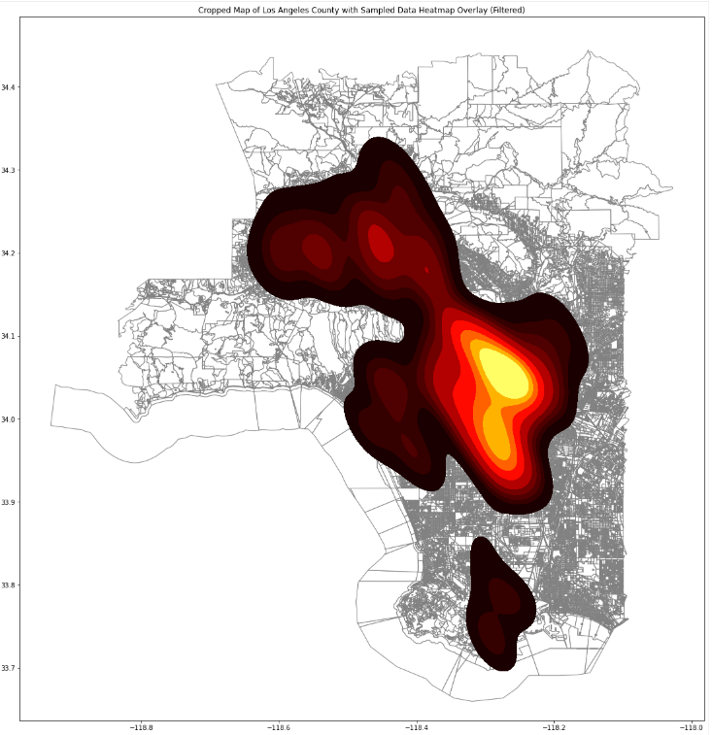

That’s looking better.

Let’s try something else for fun. A play around with size and colors

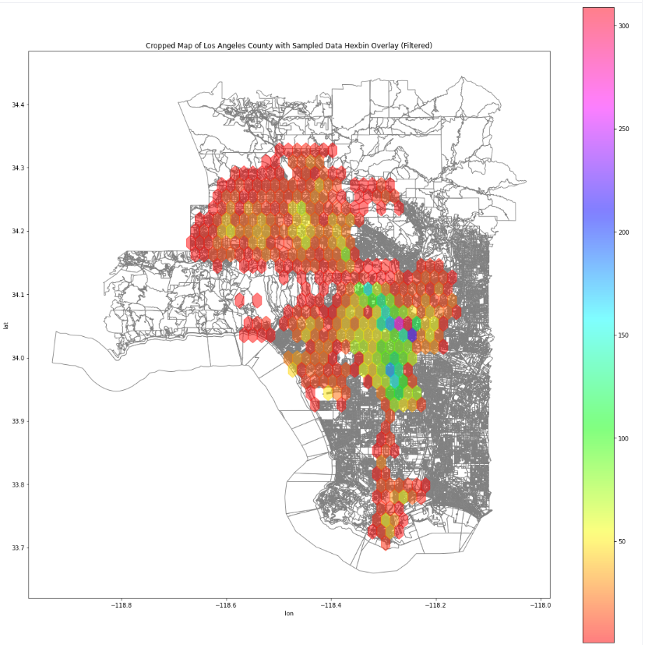

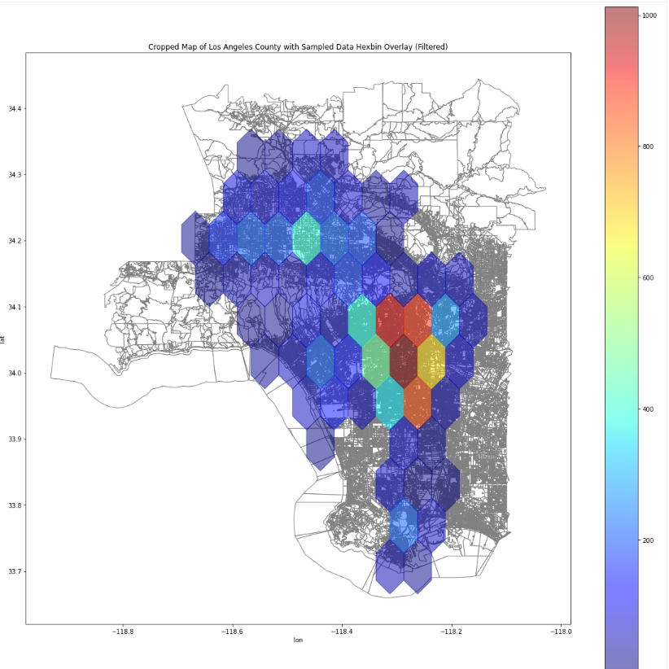

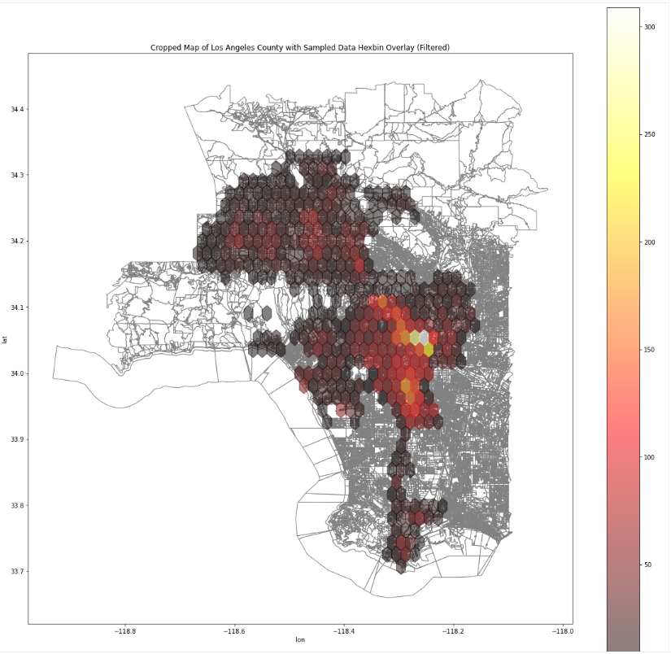

Now the two interactive ones. This ones allow me to zoom, drag, select and do all sorts of fun stuff.

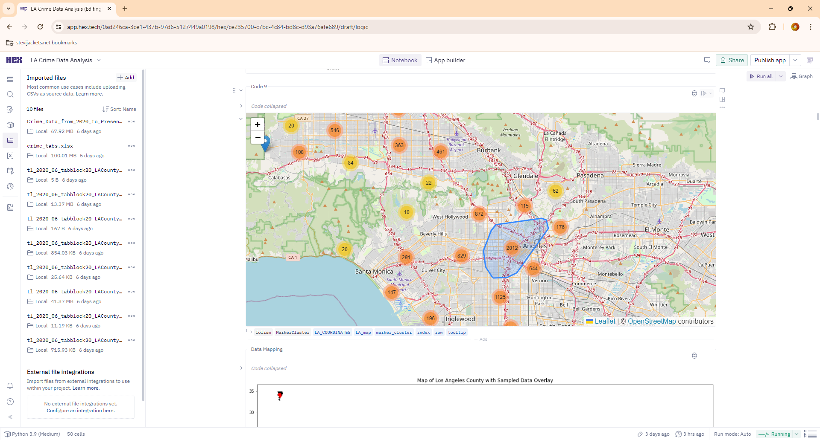

Then click in again and again. Until I’m on a pin and then it gives me any information that I want.

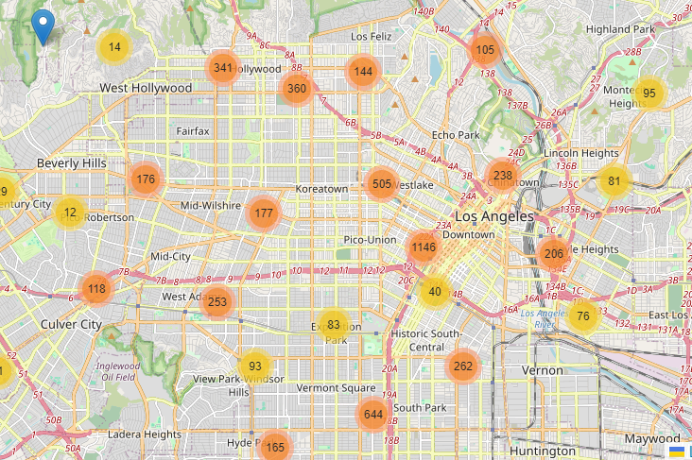

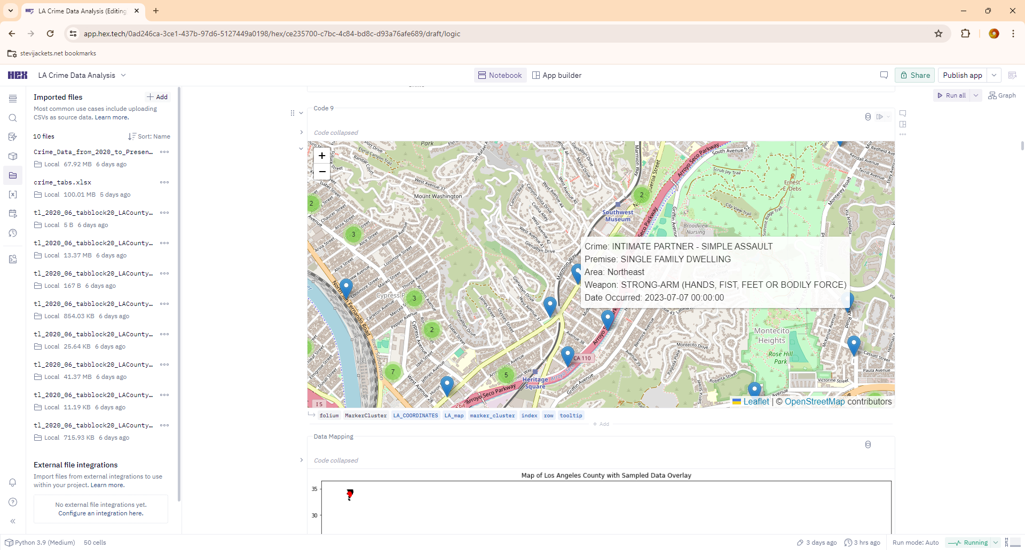

Here is something similar but with heat pins and no clusters.

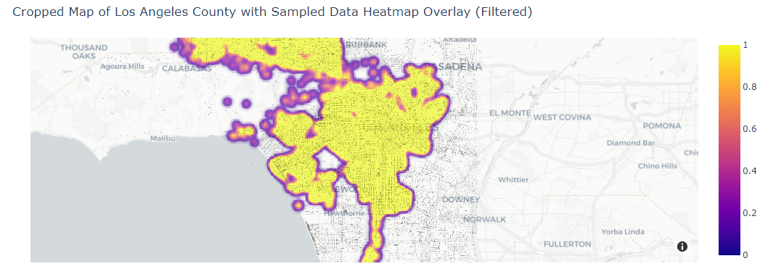

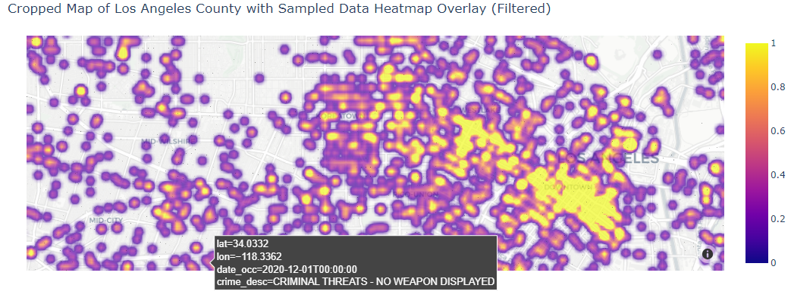

You can zoom and drag to any area and get something like this.

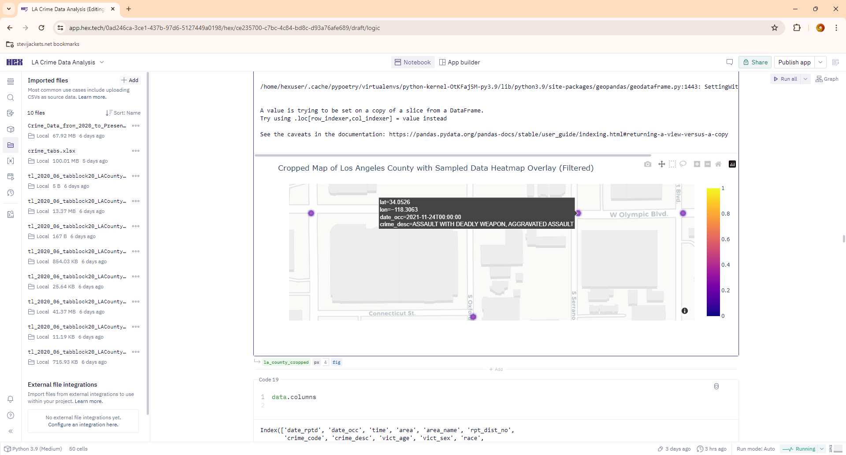

* **A summary of the key elements of your design and accompanying justification**

I learned a lot from this assignment. I had a fun time trying out different color schemes and combinations of data. Building interactive graphs and charts and deciding what and how to display the information. There were countless iterations not pictured above, plenty of mistakes and code that just didn’t work. I’m still not very happy with the hovering displays. The bar charts I decided to keep the bars all the same color as they were talking about the same category. If I had made an overlade bar chart, just thought of it right now, I would use different colors. The Line Graphs with multiple years overlaid, I like how each line was distinct. The first heat maps, not on a map, I played around with lots of colors and found that less was more, until I figured out the log scale, but I didn’t like bright colors on that one. It gave the sense of some things being more important than others. The heat map of L.A. County was interesting to say the least, the non-interactive one took more work. Finding the correct files to download that interact with the CSV file was tricky. Even though they aren’t the neatest looking, they are the ones that I’m the proudest of. The interactive ones are cool, and the code was a lot easier, but I still like the other ones more.

* **A discussion of your final evaluation approach, including the procedure, people recruited, and results.**

I didn’t think that this part of the process would be very insightful or useful. I’m happy to say that I was wrong. Once I got into it, I found it the most rewarding in the end. I implemented almost every suggestion. I was happy when the evaluator wanted something and then I already had it in my next iteration of the design. I tested it out on work colleagues, my wife, and kids, finally my father, who just happens to be ex law enforcement. So, looking at crime in L.A. was right up his alley. I took a “ThinkaLoud” approach. It was very insightful just sitting back and watching him play and talk about the data in real time. I had to make a conscious effort to not talk or explain things. He had the most insightful things to say and wanted to know specific things about each data point and wanted everything to be interactive and wanted to know the date of each crime. I was surprised that he liked the black and red fluid heat map the most, not the ones with the hexes. He really liked the interactive ones, but he wanted more data about each point than I originally had displayed. I followed his advice and loaded it into the “cluster” one.

* **A synthesis of your findings, including what elements of your approach worked well and what elements you would refine in future iterations.**

I was really surprised with the high correlation in crime by hour over a 4-year period. Even down to the least amount of crime being at 5 am and a spike at 12 noon. This was all the crime with weapons 24 hours a day for 1460 days (4 yrs). Such high correlation. It was difficult working with basically all categorical data. I’m glad I got the heat maps to work or there wouldn’t be anything to really show or talk about. The visual corridor between central L.A. and the coast was interesting. It looks like crime goes in a straight line. I’m sure there is crime in other places, but it just looks like a corridor. I can tell you the most prevalent types of crime, in the most prevalent locations with the most prevalent type of weapon. My father found this very interesting, he talked about what he would want to know as ex law enforcement and how he would want to use the data. He talked about how different departments would want to know different things and how they would use the location and frequency data to assign officers to different locations. I would want to know if there was a difference in reported crime and crime the officers just stumbled across. Talking to my father, most crime is reported, very little is discovered by police just walking a beat trying to deter crime. But it would be an interesting piece of the overall picture. He was interested in traffic crime, which I didn’t focus on. I felt that talking to my dad and getting a sense of what the “client” might want to know differed from what I thought was important or interesting. I think in the future I might schedule a quick conference call with clients or stakeholders and see if what I’m doing is appropriate or beneficial. So that I can provide a quality service and focus or change the direction as needed. I would play around with the presentation of the data if I were to present it to others. Meet the brief, so to speak.

In conclusion, I found this to be the most rewarding data visualization project to date. It was interesting to work with so much categorical data and seeing what types of information or story it could tell. To see the power or impact of a simple color change or the interactive power at work in real time. I look forward to future projects.